GreenCar@UoL Black-box Testing, BSc Computing Final Project

# Registration

|  |  |  |  |  |
| --- | --- | --- | --- | --- |
| Test No# | Title | Expected | Actual | Result |
| 1. | Registering with correct details as a rider | User will be registered, taken to Home Screen & details stored into Firebase | User registered, taken to Home Screen with details stored | PASS |
| 2. | Registering with correct details as a driver | User will be registered, taken to Home Screen & details stored into Firebase | User registered, taken to Home Screen with details stored | PASS |
| 3. | Registering with incorrect details as a rider | Error Message shown to user if missing fields | Error Message Shown | PASS |
| 4. | Registering with incorrect details as a driver | Error Message shown to user if missing fields | Error Message Shown | PASS |

## Registering with correct details as a rider

Registering with the following details:

Name: Rider Test

Email: [rider@test.com](mailto:rider@test.com)

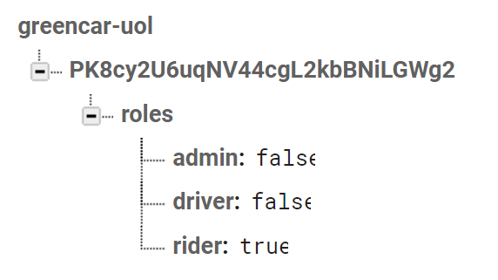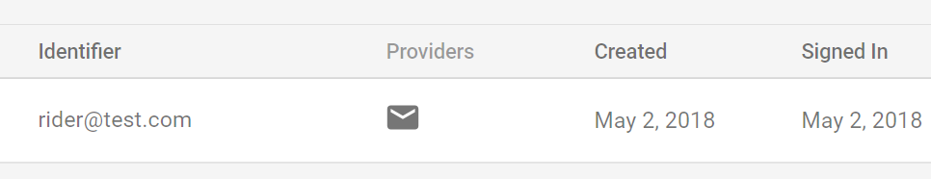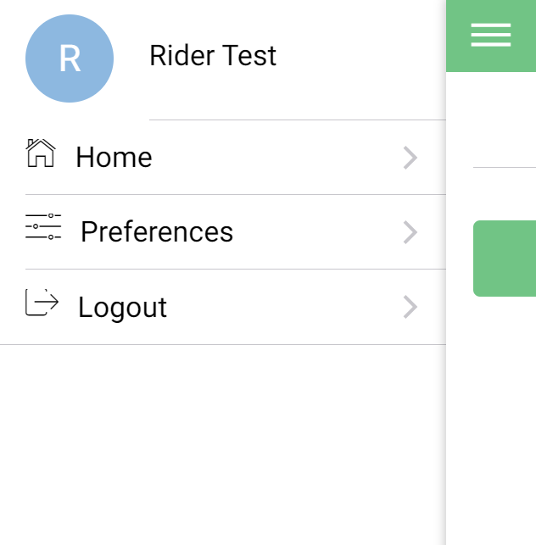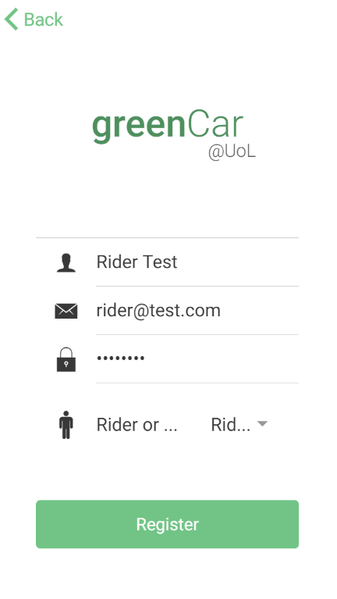Password: password

## Registering with correct details as a driver

Name: Driver Test

Email: [driver@test.com](mailto:driver@test.com)

Password: password

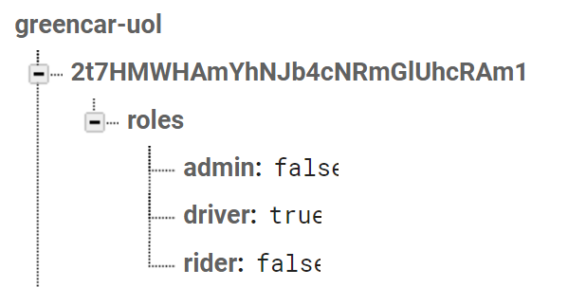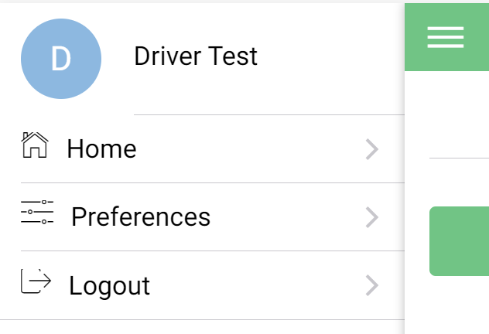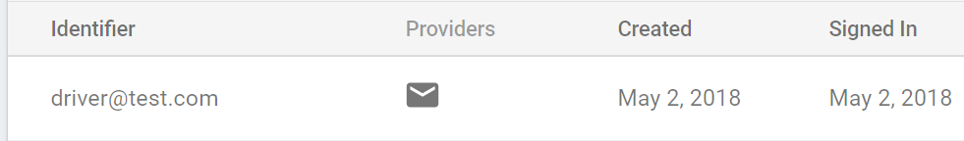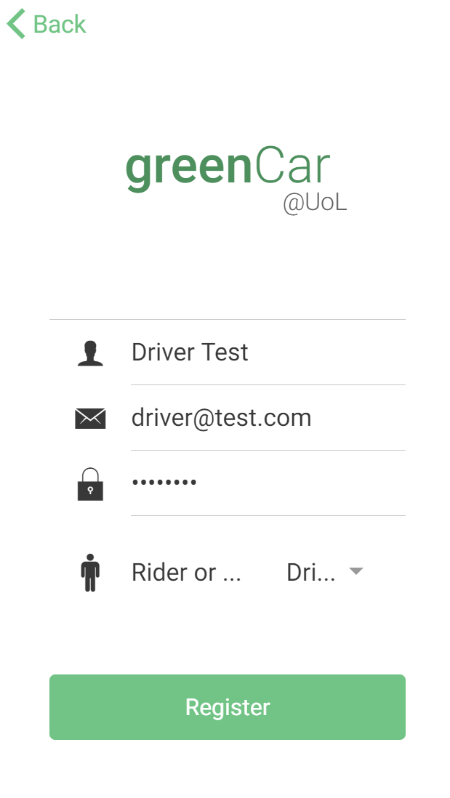

## Registering with incorrect details as a rider details

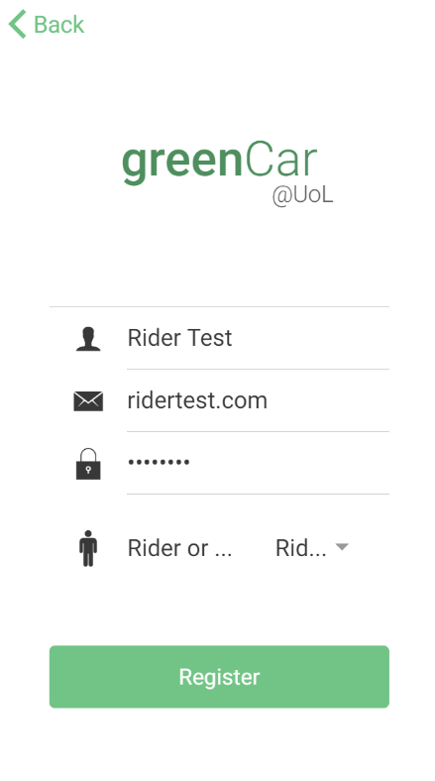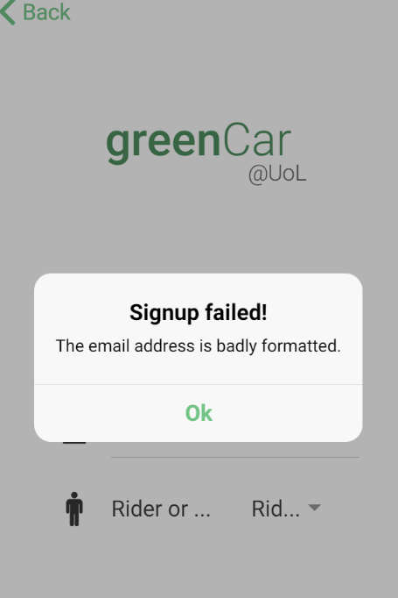Name: Rider Test

Email: [ridertest.com](mailto:driver@test.com)

Password: password

## Registering with incorrect details as a driver

Name: Driver Test

Email: [drivertest.com](mailto:driver@test.com)

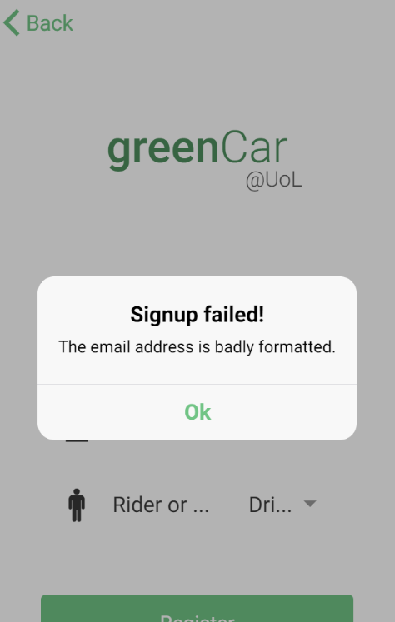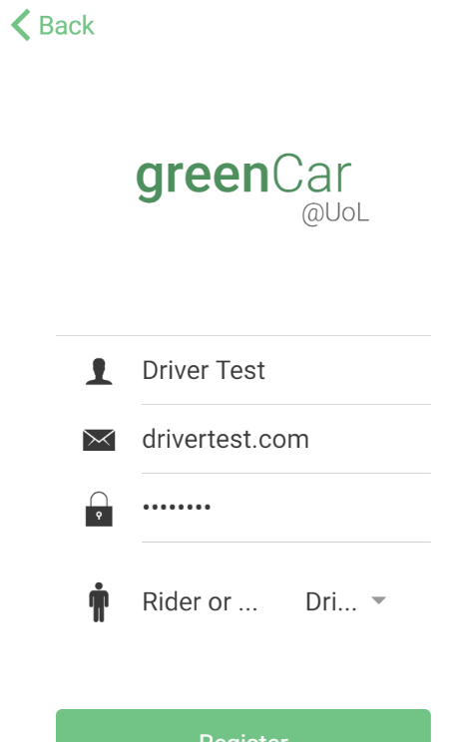Password: password

# Login & Logout

|  |  |  |  |  |
| --- | --- | --- | --- | --- |
| Test No# | Title | Expected | Actual | Result |
| 1. | Login with correct details | User successfully logged in | User logged in successfully | PASS |
| 2. | Login with incorrect details | User shown incorrect details message | User shown error message | PASS |
| 3. | Logout once logged in | User presses logout & is taken back to Login Screen | User logged out, taken to login screen | PASS |

## Login with correct details

Email: [rider@test.com](mailto:rider@test.com)

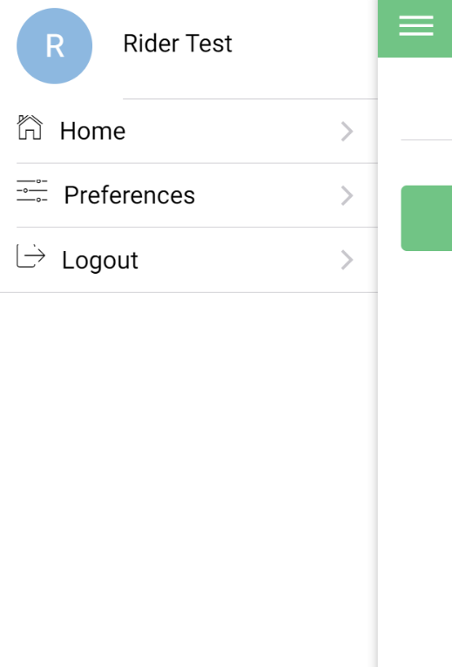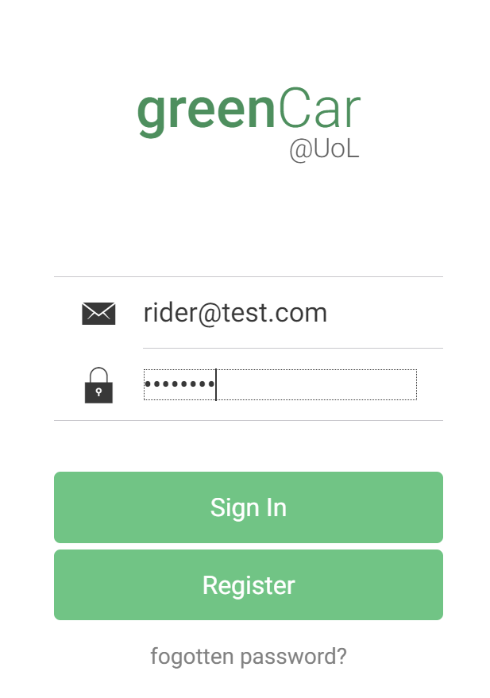Password: password

## Login with incorrect details

Username: incorrect@test.com

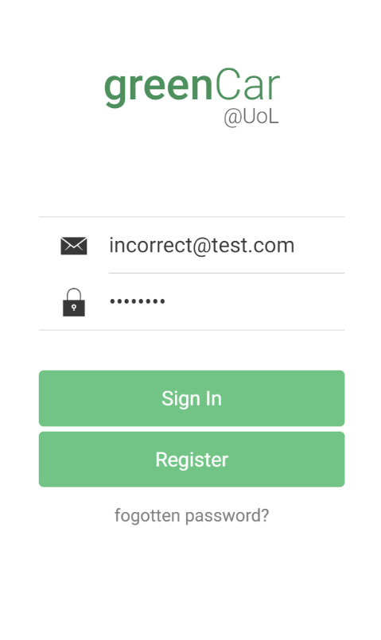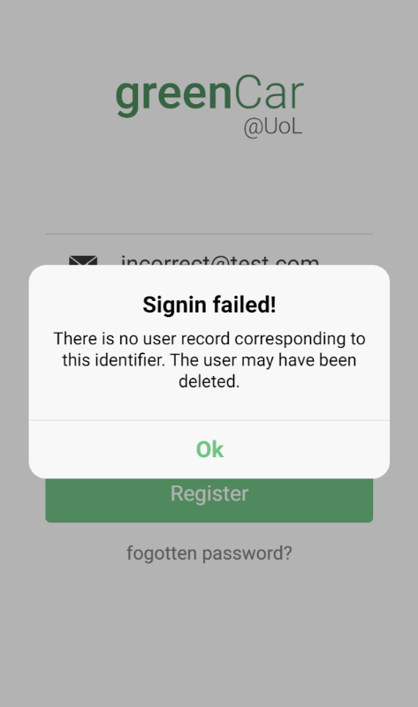Password: password

## Logout once logged in

Username: [rider@test.com](mailto:rider@test.com)

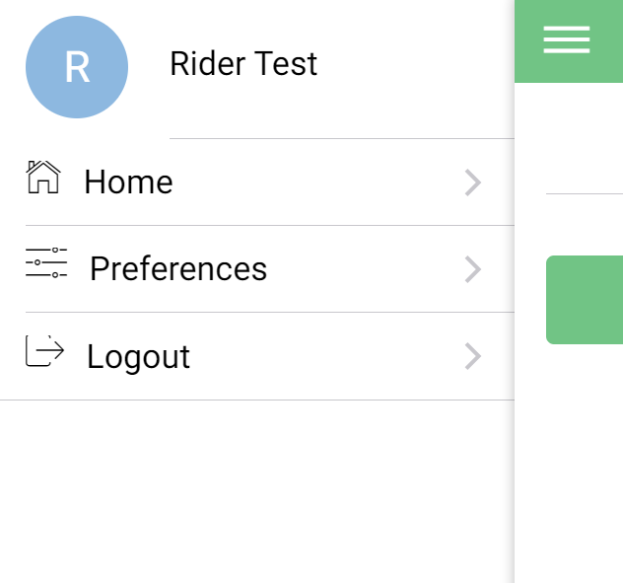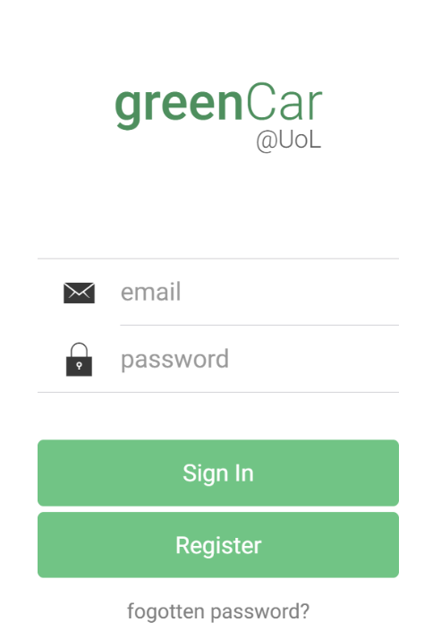Password: password

# Preferences

|  |  |  |  |  |
| --- | --- | --- | --- | --- |
| Test No# | Title | Expected | Actual | Result |
| 1. | Save Units of distance to KM | Units of distance are saved as ‘km’ in Firebase | New Distance saved to Firebase | PASS |
| 2. | Save Units of distance to Miles | Units of distance are saved as ‘miles’ in Firebase | New Units saved to Firebase | PASS |
| 3. | Save Meeting Radius | Radius is saved to Firebase | New Radius saved to Firebase | PASS |
| 4. | Save Allowed Wait Time | Allowed Wait Time is saved to Firebase | New wait time saved to Firebase | PASS |
| 5. | Reset Preferences & Save | Preferences are reset and saved to Firebase | Preferences Reset & Saved to Firebase | PASS |

## Save Units of Distance to KM

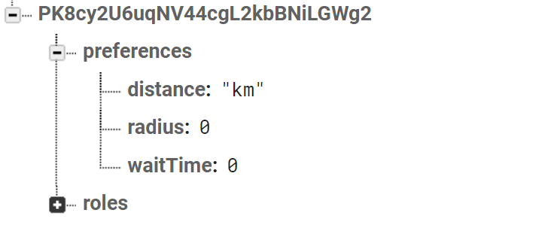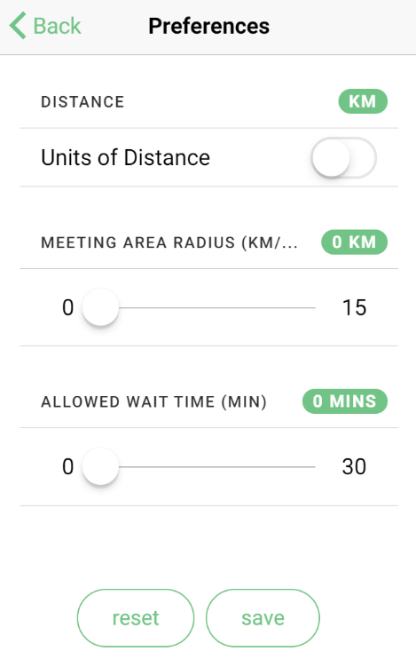

## Save Units of Distance to Miles

## Save Meeting Radius

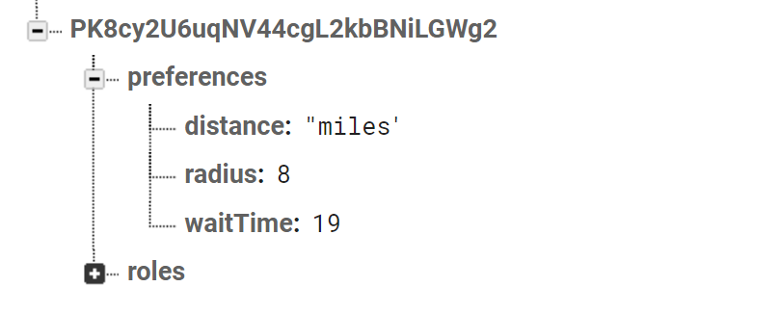

## Save Allowed Wait Time

## Reset Preferences

# Journey Creation – Adding Routes

|  |  |  |  |  |
| --- | --- | --- | --- | --- |
| Test No# | Title | Expected | Actual | Result |
| 1. | Click ‘Create Journey’ > Add Route. Friar Lane to Millstone Lane | On Typing in road names in full, route is calculated on ‘confirm’ | Route calculated on confirm | PASS |
| 2. | Click ‘Create Journey’ > Add Route. Friar Lane to Queens Road | On Typing in road names in full, route is calculated on ‘confirm’ | Route calculated on confirm | PASS |
| 3. | Click ‘Create Journey’ > Add Route. Friar Lane to Millstone Lane Using Auto-Complete | On partially typing in road names, route is calculated on ‘confirm’ | Route calculated on confirm | PASS |
| 4. | Click ‘Create Journey’ > Add Route. Friar Lane to Millstone Lane, Using click-selection | On road selection route is calculated on ‘confirm’ | Route calculated on confirm | PASS |
| 5. | Click ‘Create Journey’ > Add Route. Friar Lane to Millstone Lane, Adjusting using dragging to Hotel Street | On selecting a route, after re-adjustment, route is calculated on ‘confirm’ | Route calculated on confirm | PASS |

## Click ‘Create Journey’ > Add Route. Friar Lane to Millstone Lane

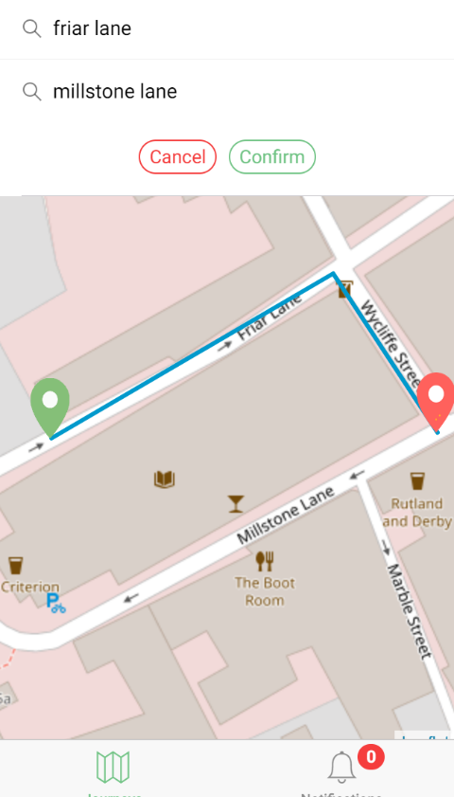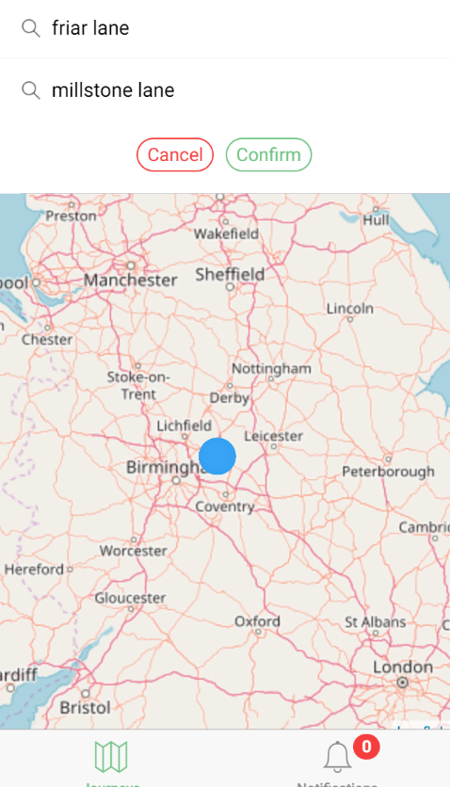

## Click ‘Create Journey’ > Add Route. Friar Lane to Queens Road

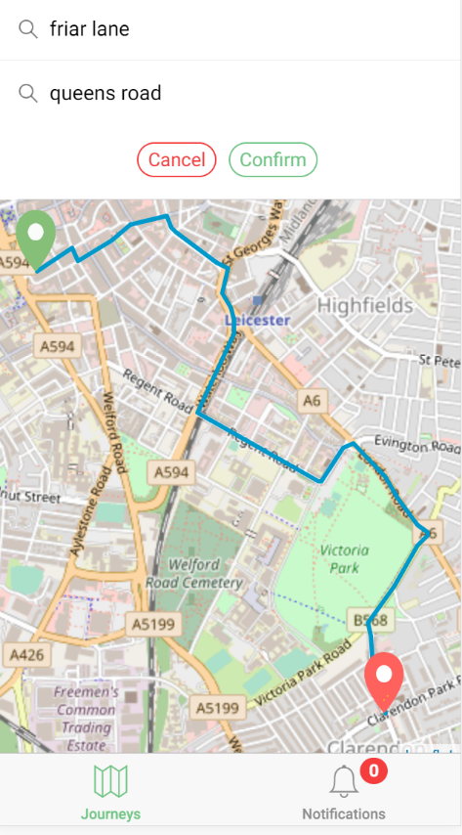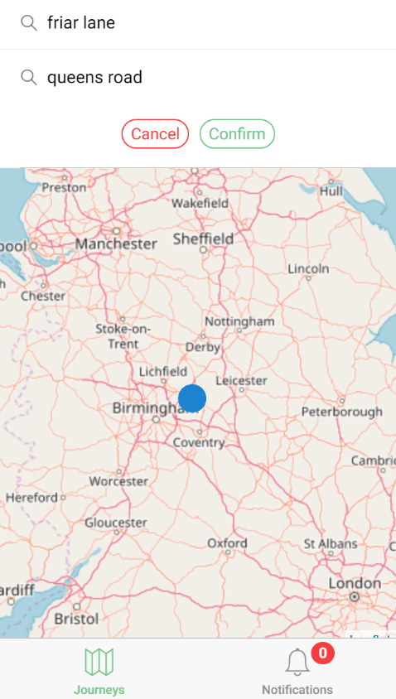

## Click ‘Create Journey’ > Add Route. Friar Lane to Millstone Lane Using Auto-Complete

## Click ‘Create Journey’ > Add Route. Friar Lane to Millstone Lane, Using click-selection

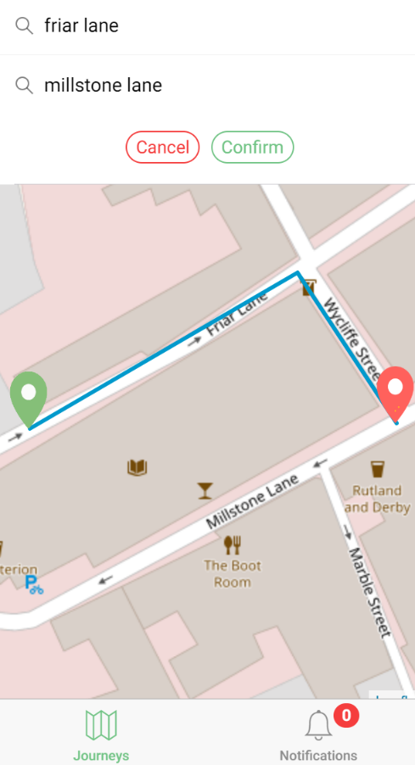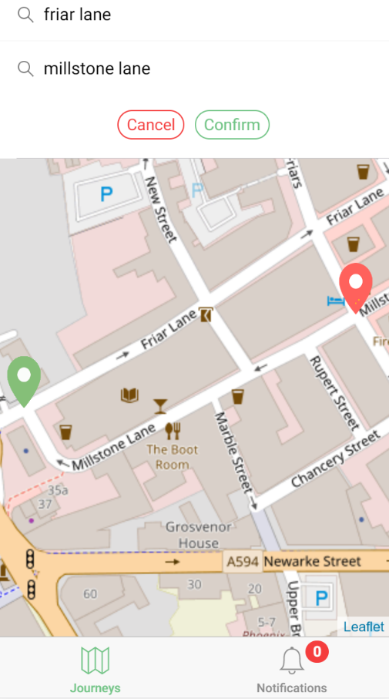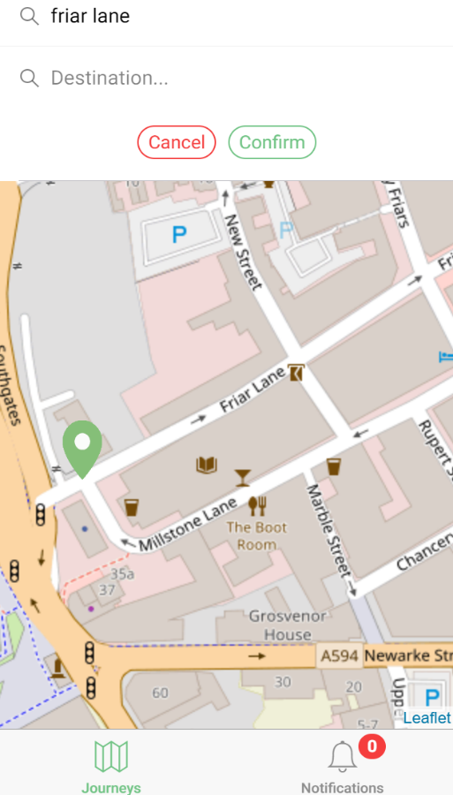

## Click ‘Create Journey’ > Add Route. Friar Lane to Millstone Lane, Adjusting using dragging to Hotel Street

# Journey Creation - Driver

|  |  |  |  |  |
| --- | --- | --- | --- | --- |
| Test No# | Title | Expected | Actual | Result |
| 1. | Creation of Journey with valid start-date & pickup time – non repeating | Journey Created without issue & saved to firebase | Journey Created without issue & saved to firebase | PASS |
| 2. | Creation of Journey with valid start-date & pickup time – repeating | Journey Created without issue & saved to firebase | Journey Created without issue & saved to firebase | PASS |
| 3. | Creation of Journey with missing details | Error Message shown to user | Error Message shown to user | PASS |
| 4. | Creation of Journey with missing details - repeating | Error Message shown to user | Error Message shown to user | PASS |

## Creation of Journey with valid start-date & pickup time – non repeating

## Creation of Journey with valid start-date & pickup time – repeating

## Creation of Journey with missing details

Missing Route

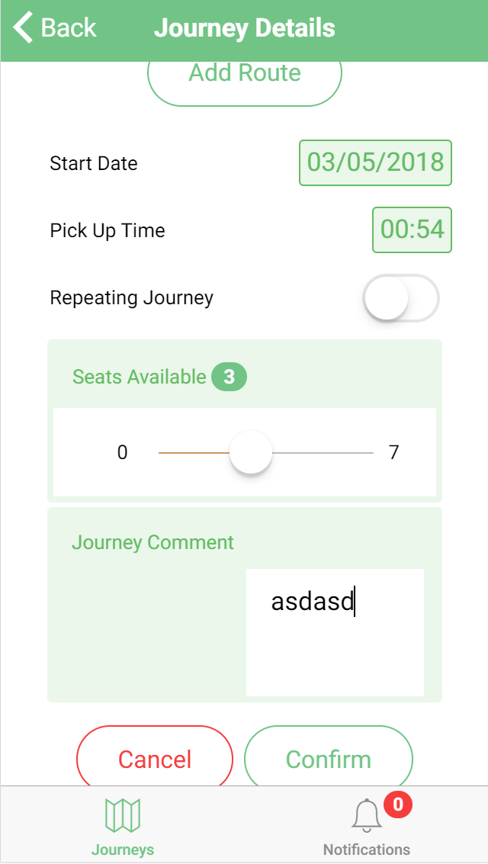 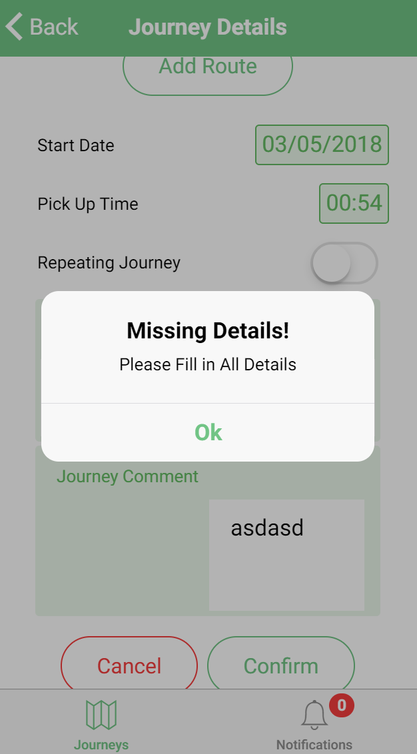

## Creation of Journey with missing details – repeating

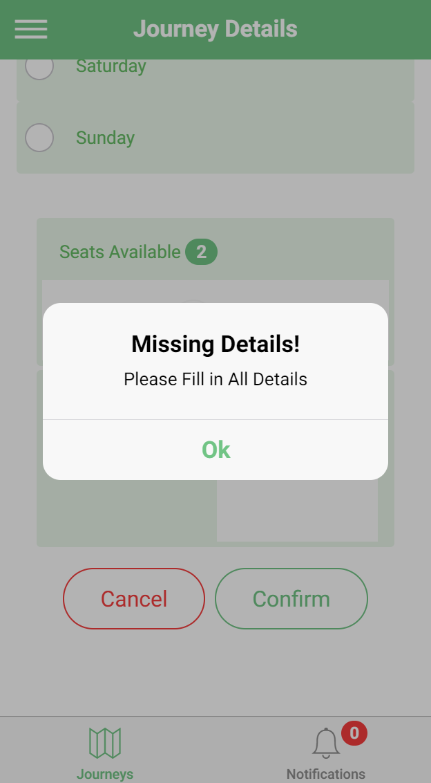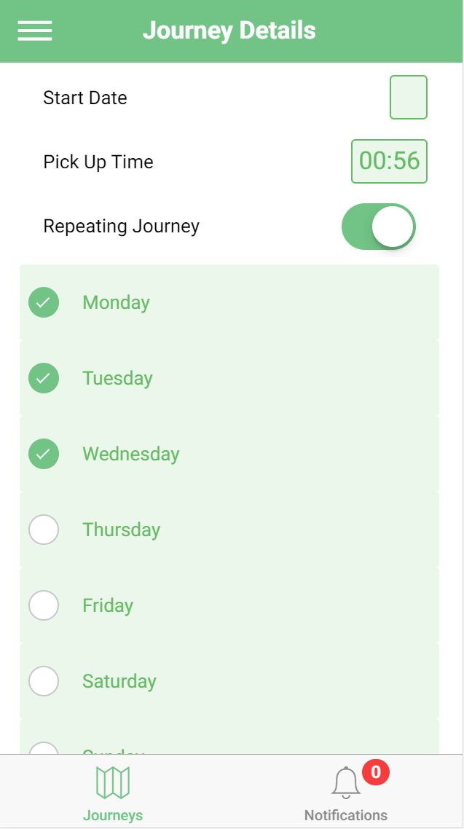

# Journey Creation - Rider

|  |  |  |  |  |
| --- | --- | --- | --- | --- |
| Test No# | Title | Expected | Actual | Result |
| 1. | Creation of Journey with valid start-date & pickup time – non repeating | Journey Created without issue & saved to firebase | Journey Created without issue & saved to firebase | PASS |
| 2. | Creation of Journey with valid start-date & pickup time – repeating | Journey Created without issue & saved to firebase | Journey Created without issue & saved to firebase | PASS |
| 3. | Creation of Journey with missing details | Error Message shown to user | Error Message shown to user | PASS |
| 4. | Creation of Journey with missing details - repeating | Error Message shown to user | Error Message shown to user | PASS |

## Creation of Journey with valid start-date & pickup time – non repeating

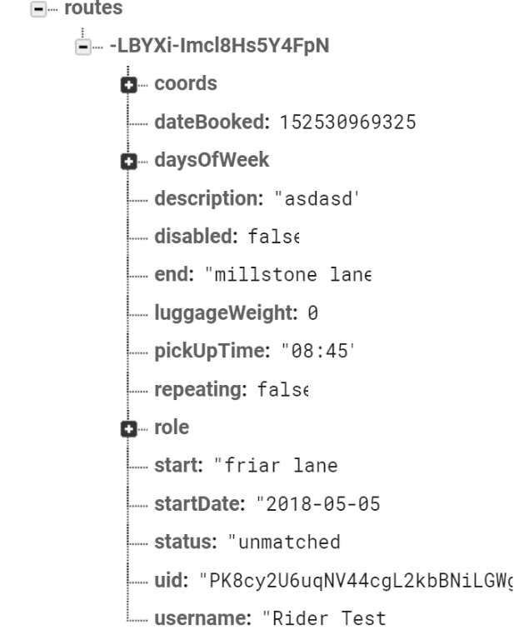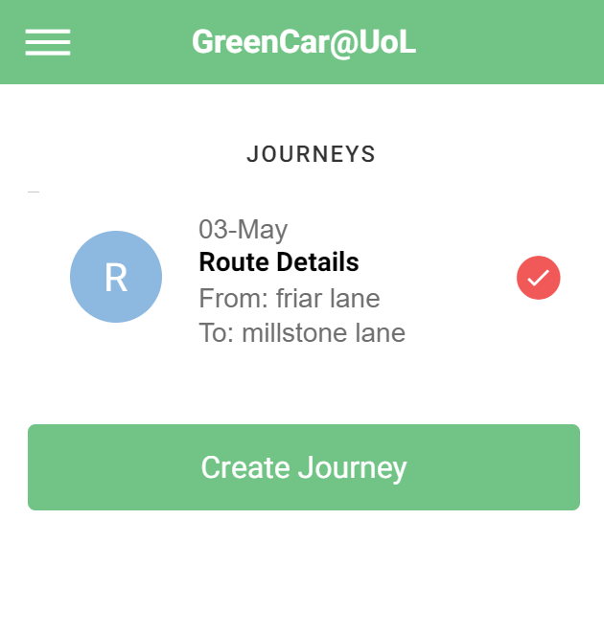 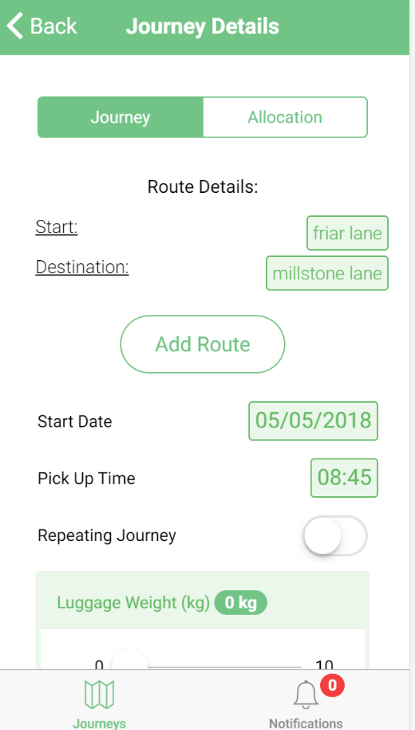

## Creation of Journey with valid start-date & pickup time – repeating

## Creation of Journey with missing details

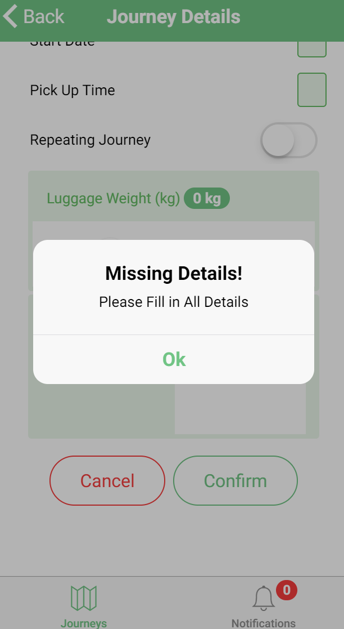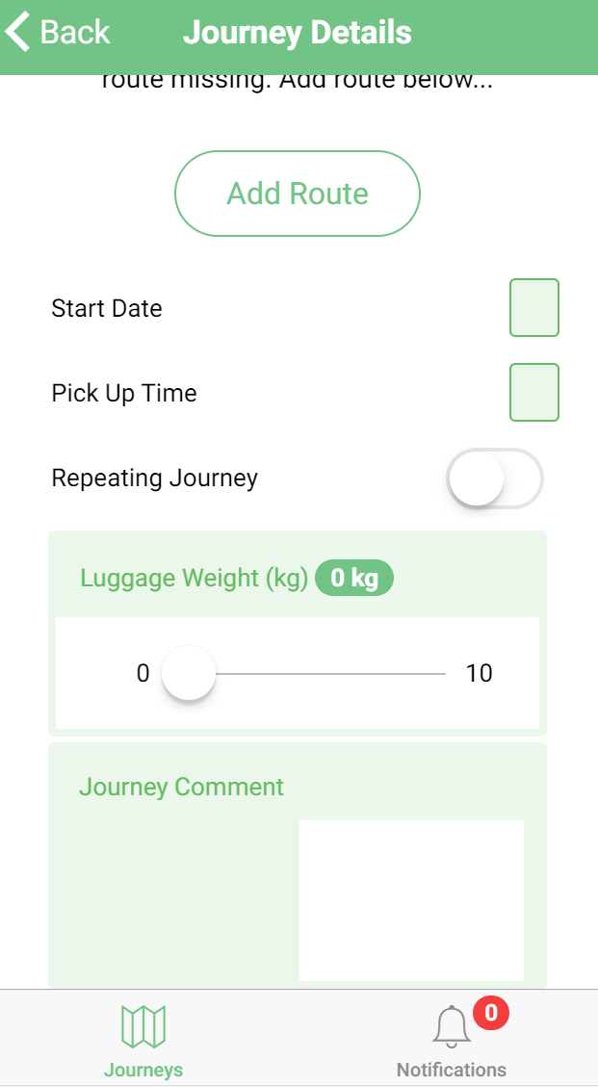

## Creation of Journey with missing details - repeating

# Journey Deletion/Disable

|  |  |  |  |  |
| --- | --- | --- | --- | --- |
| Test No# | Title | Expected | Actual | Result |
| 1. | Deletion of Journey | Journey Deleted from View and removed from Firebase | Journey is deleted from view and removed from Firebase | PASS |
| 2. | Disable Journey | Journey is disabled in view and Firebase | Journey is disabled in view and Firebase | PASS |

## Journey Deletion

## Disable Journey

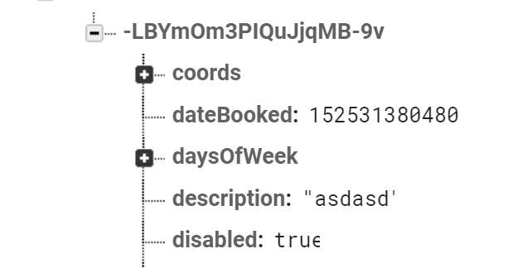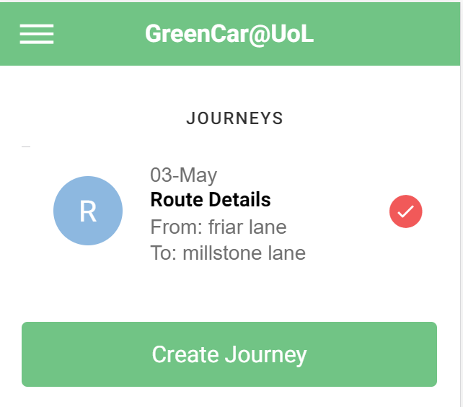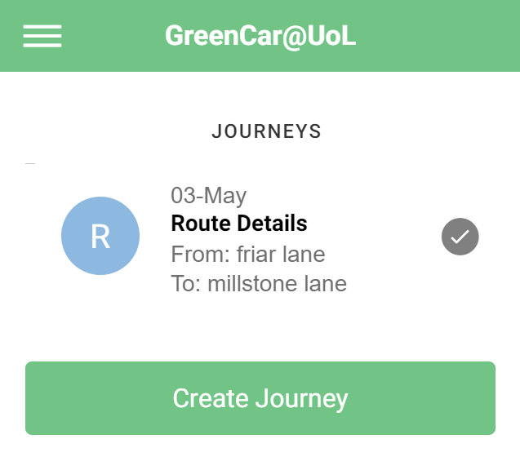

# Matching

|  |  |  |  |  |
| --- | --- | --- | --- | --- |
| Test No# | Title | Expected | Actual | Result |
| 1. | Create Driver Journey, Create Rider Journey within 1km, match both | Rider journey will match with driver journey | Rider matched properly | PASS |
| 2. | Create Driver Journey, Create Rider Journey outside of 1km, not matched | Rider will be unable to see driver journey | Rider was unable to see driver journey | PASS |
| 3. | Once Driver and Rider matched, Rider Requests Match & Driver receives Notification | Driver will receive rider request to join | Driver received request | PASS |
| 4. | Driver Accepts Notification & Rider joins journey | Once Driver accepts request, rider will be notified of accepted request | Rider notified and matched into journey | PASS |
| 5. | Multiple Riders request to join driver journey | Driver can respond to multiple rider requests | Driver could accept multiple riders | PASS |

## Create Driver Journey, Create Rider Journey within 1km, match both

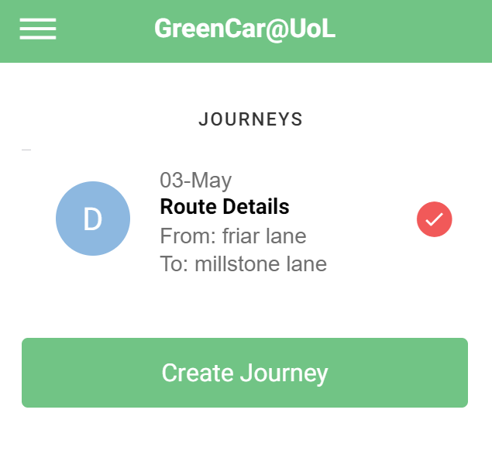 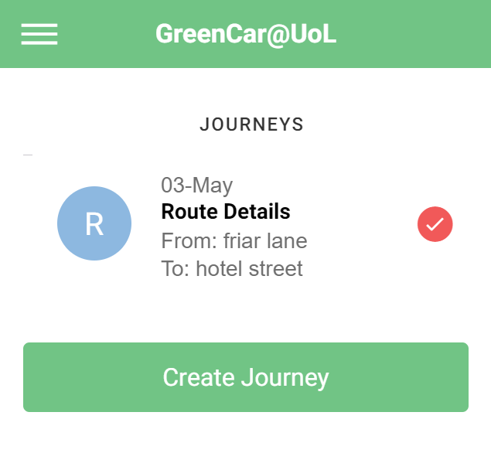

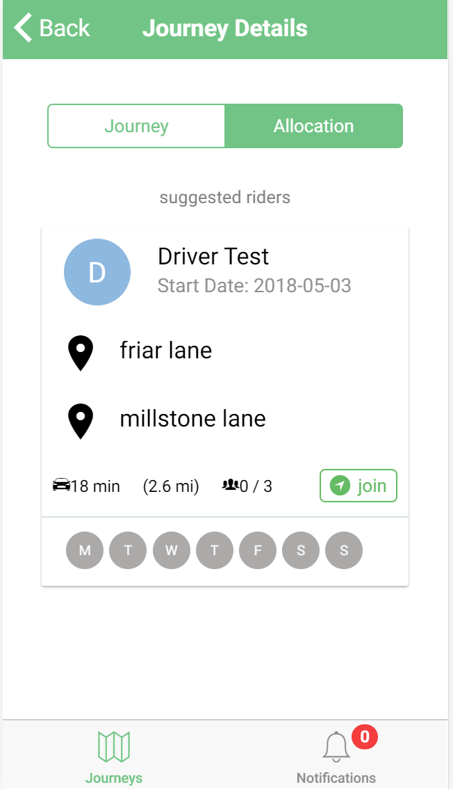

## Create Driver Journey, Create Rider Journey outside of 1km, not matched

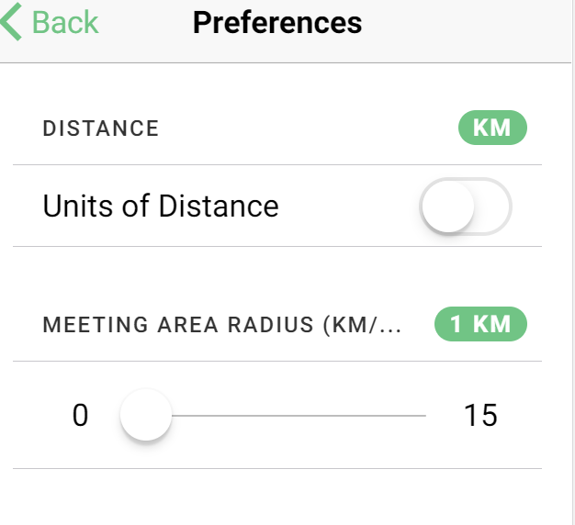Rider Details

Driver Details



No Matches

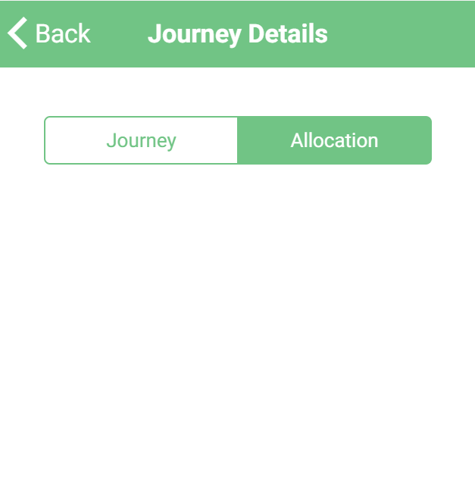

## Once Driver and Rider matched, Rider Requests Match & Driver receives Notification

Rider

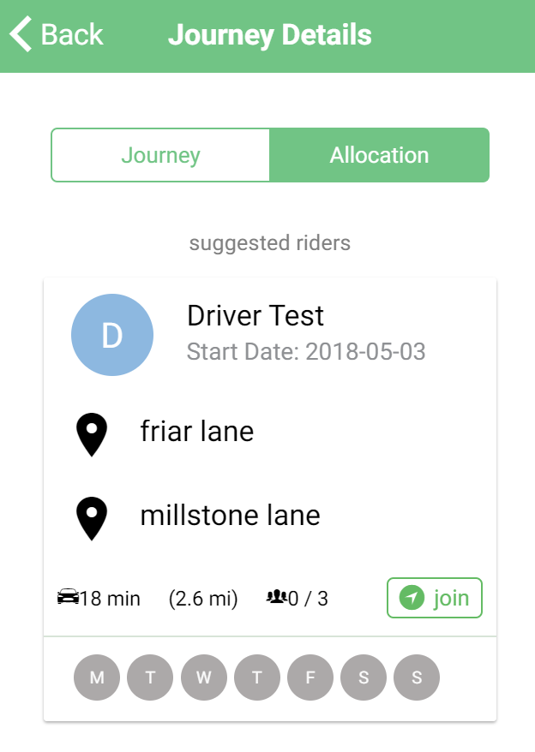 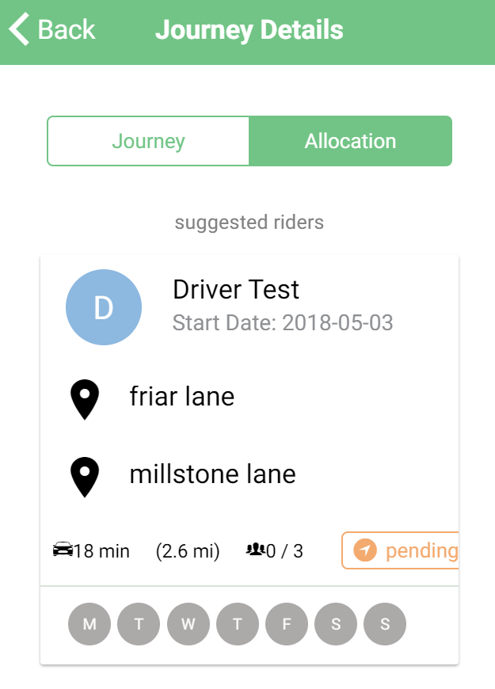

Driver

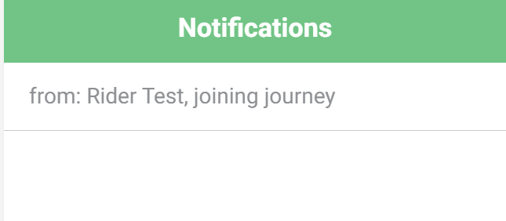 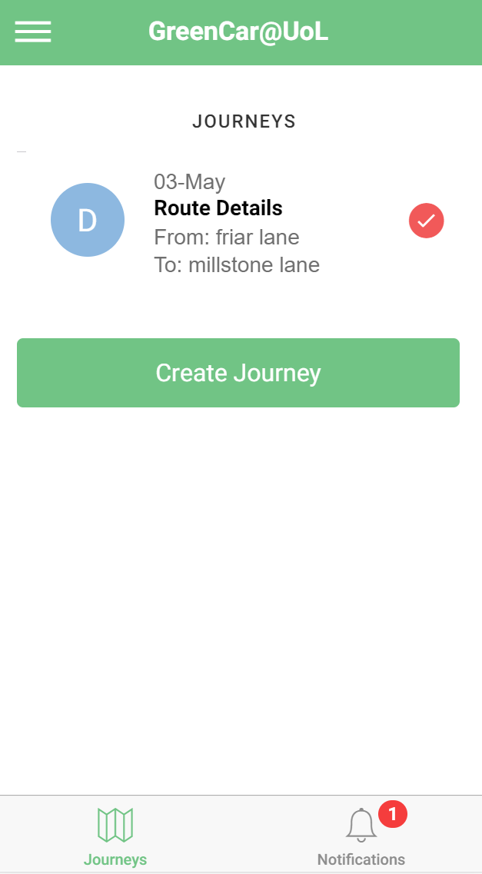

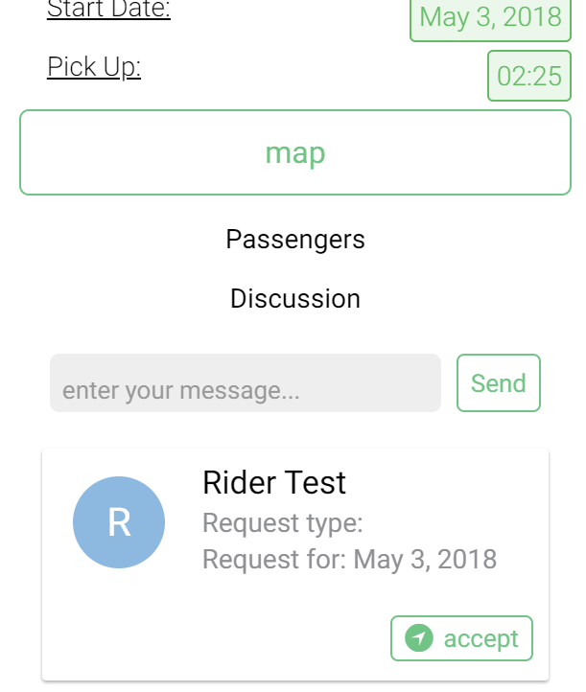

## Driver Accepts Notification & Rider joins journey

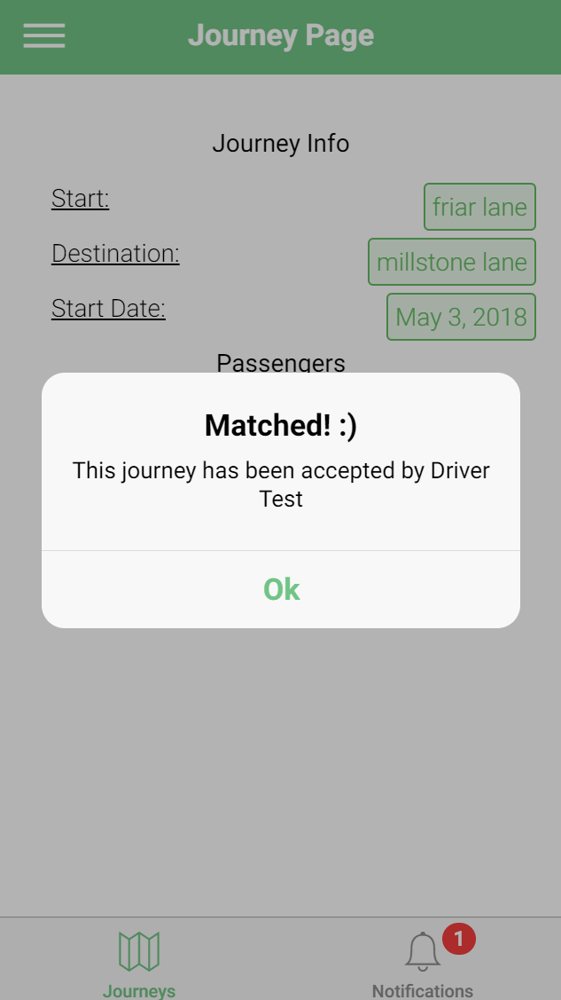 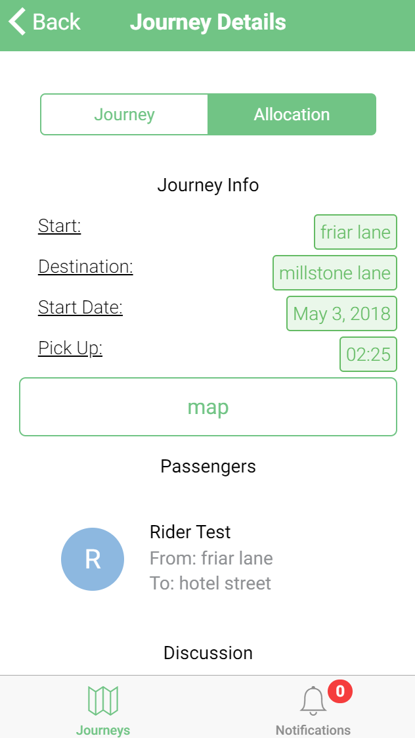

## Multiple Riders request to join driver journey

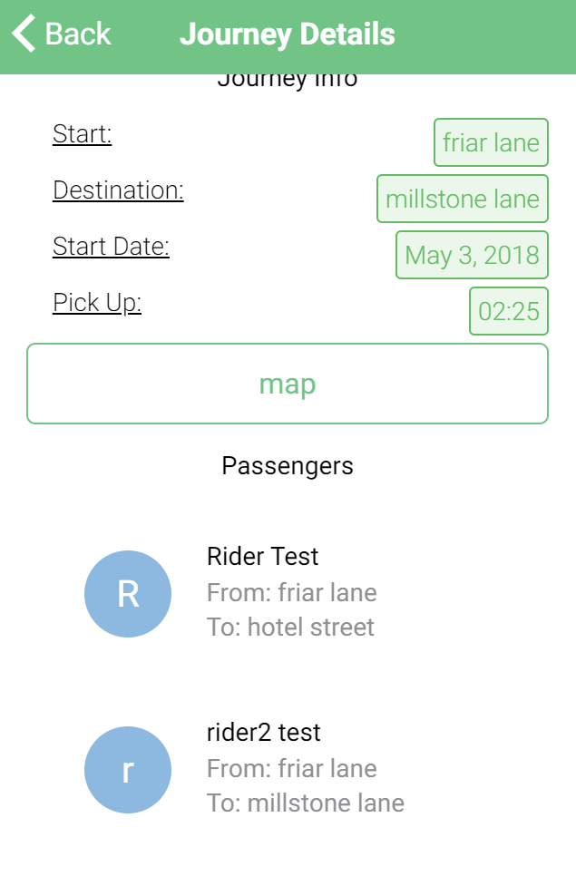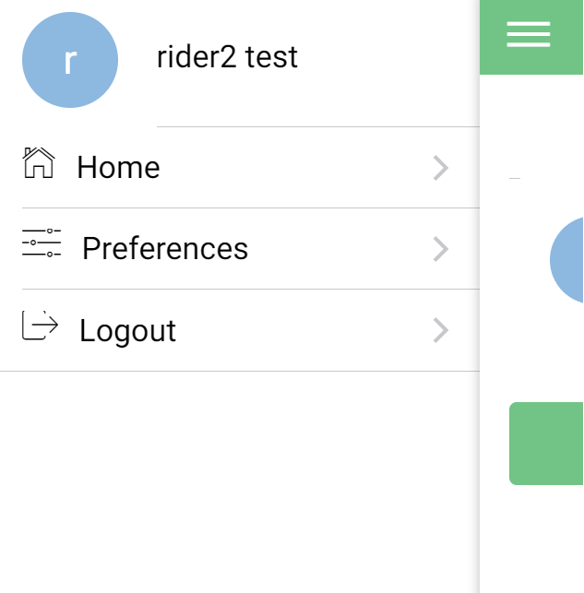

# Messaging

|  |  |  |  |  |
| --- | --- | --- | --- | --- |
| Test No# | Title | Expected | Actual | Result |
| 1. | Rider messages within group journey | Rider can send a message to journey | Riders message is sent, and seen by others | PASS |
| 2. | Driver messages within group journey | Driver can send a message to journey | Drivers message is sent, and seen by others | PASS |
| 3. | Rider can message another rider within journey | Rider can messages another rider, and is seen by second rider | Riders message is sent an received by second rider | PASS |

## Rider messages within group journey

## Driver messages within group journey

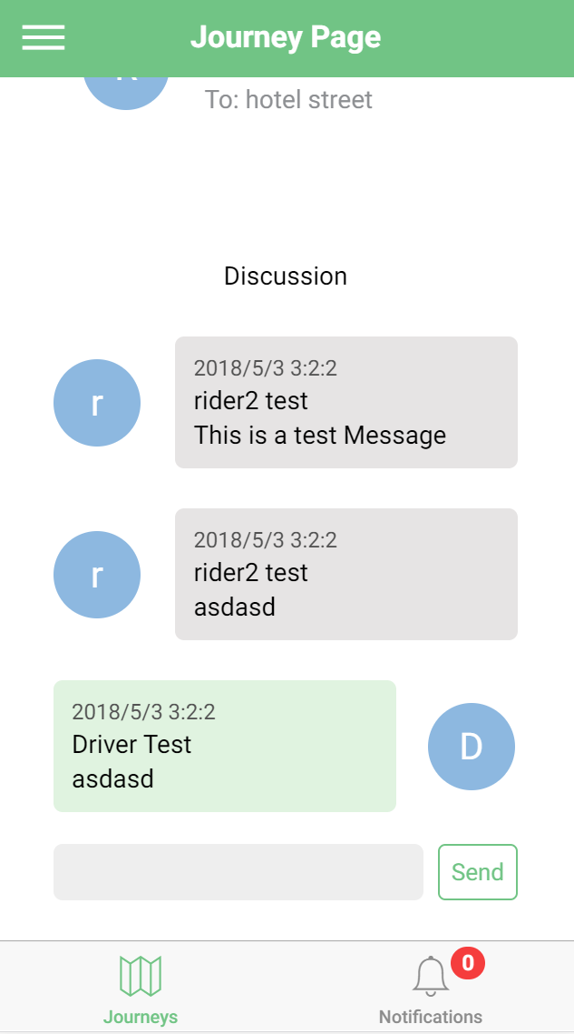 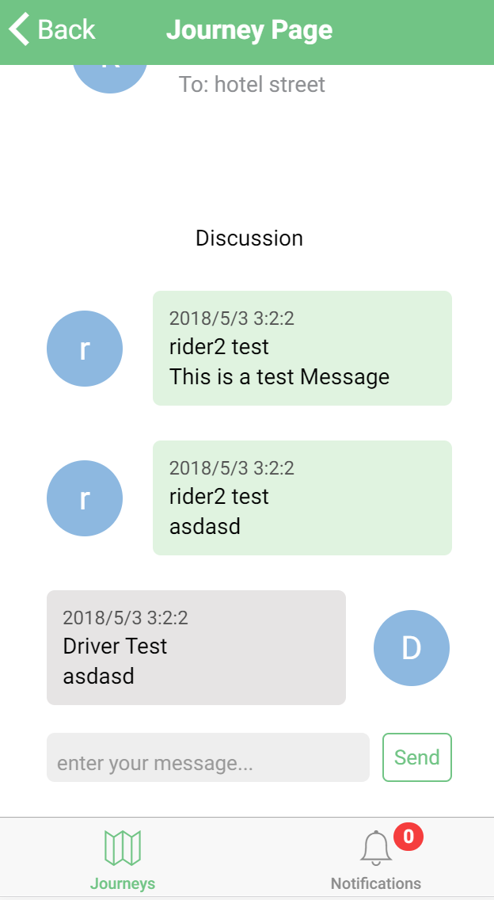

## Rider can message another rider within journey

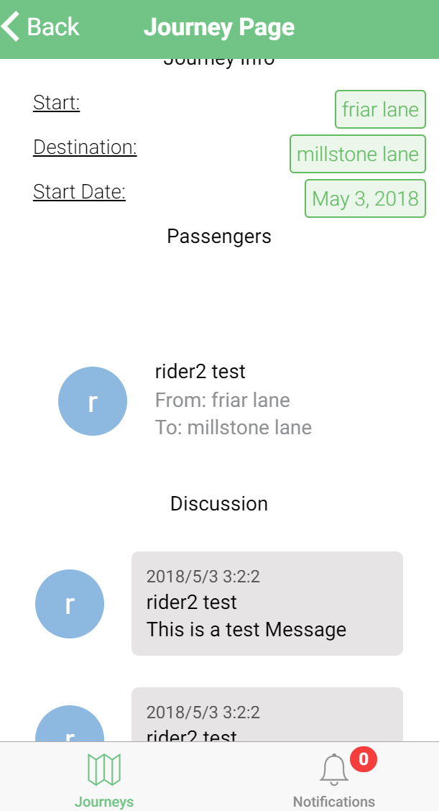Rider 2 View Rider 1 View

